**Data Structures and Algorithms**

**Exercise-1: E-Commerce Platform Search Function**

**Program.cs:**

using System;

class Program

{

static void Main()

{

Product[] products = new Product[]

{

new Product(1, "Laptop", "Electronics"),

new Product(2, "Shirt", "Clothing"),

new Product(3, "Phone", "Electronics"),

new Product(4, "Book", "Education")

};

Console.WriteLine(" Linear Search:");

var linearResult = SearchDemo.LinearSearch(products, "Phone");

Console.WriteLine(linearResult != null ? linearResult.ToString() : "Product not found");

Array.Sort(products, (x, y) => x.ProductName.CompareTo(y.ProductName));

Console.WriteLine("\n Binary Search:");

var binaryResult = SearchDemo.BinarySearch(products, "Phone");

Console.WriteLine(binaryResult != null ? binaryResult.ToString() : "Product not found");

Console.ReadKey();

}

}

**Search Demo.cs:**

using System;

public static class SearchDemo

{

public static Product LinearSearch(Product[] products, string name)

{

foreach (var product in products)

{

if (product.ProductName.Equals(name, StringComparison.OrdinalIgnoreCase))

return product;

}

return null;

}

public static Product BinarySearch(Product[] products, string name)

{

int left = 0;

int right = products.Length - 1;

while (left <= right)

{

int mid = (left + right) / 2;

int comparison = string.Compare(products[mid].ProductName, name, true);

if (comparison == 0)

return products[mid];

else if (comparison < 0)

left = mid + 1;

else

right = mid - 1;

}

return null;

}

}

**Product.cs:**

public class Product

{

public int ProductId { get; set; }

public string ProductName { get; set; }

public string Category { get; set; }

public Product(int id, string name, string category)

{

ProductId = id;

ProductName = name;

Category = category;

}

public override string ToString()

{

return $"ID: {ProductId}, Name: {ProductName}, Category: {Category}";

}

}

**Output:**

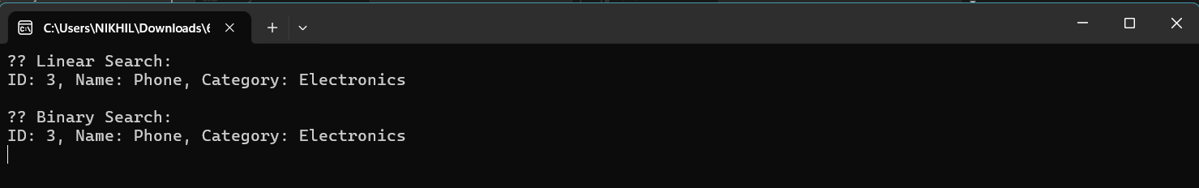

**Exercise-2:Financial Forecasting**

**Program.cs:**

using System;

namespace FinancialForecasting

{

class Program

{

static void Main(string[] args)

{

Console.WriteLine(" Financial Forecasting Tool");

Console.Write("Enter current value: ");

double currentValue = Convert.ToDouble(Console.ReadLine());

Console.Write("Enter annual growth rate (e.g., 0.05 for 5%): ");

double growthRate = Convert.ToDouble(Console.ReadLine());

Console.Write("Enter number of years: ");

int years = Convert.ToInt32(Console.ReadLine());

Forecaster forecaster = new Forecaster();

double futureValue = forecaster.PredictFutureValue(currentValue, growthRate, years);

Console.WriteLine($"\n Future Value after {years} years: {futureValue:F2}");

Console.ReadKey();

}

}

}

**Forecaster.cs:**

using System;

using System.Collections.Generic;

using System.Linq;

using System.Text;

using System.Threading.Tasks;

namespace FinancialForecasting

{

internal class Forecaster

{

public double PredictFutureValue(double currentValue, double growthRate, int years)

{

if (years == 0)

return currentValue;

return PredictFutureValue(currentValue * (1 + growthRate), growthRate, years - 1);

}

}

}

**Output:**

